A Project Report On

Silent Help – Hidden Emergency Signal App

Submitted in partial fulfillment of the requirement for the award of the degree

Master of Computer Application (MCA)

Academic Year 2025 – 26

Ankit Kumar Aftab Ansari Ankush Kumar
92500584110 92500584117 92500584141

Internal Guide
Dr.Vivek Gondalia



Rajkot-Morbi Road, At & PO : Gauridad, Rajkot 360 003. Gujarat. India.


Faculty of Computer Applications (FOCA)



This is to certify that the project work entitled
Silent Help – Hidden Emergency Signal App

submitted in partial fulfillment of the requirement for

the award of the degree of

Master of Computer Application (MCA)

of the

Marwadi University

is a result of the bonafide work carried out by

Ankit Kumar (92500584110)

Aftab Ansari (92500584117)

Ankush Kumar(92500584141)

during the academic year 2025-26

Dr. Vivek Gondalia Dr. Sunil Bajeja Dr. Rizwan Khan
Faculty Guide |  | HOD |  | Dean

DECLARATION

I/Wehereby declare that this project work entitled Contact Management System a record done by me.

I also declare that the matter embodied in this project is genuine work done by me and has not been submitted whether to this University or to any other University / Institute for the fulfillment of the requirement of any course of study.

Place : Rajkot
Date :10-04-2026

Ankit Kumar (92500584110) Signature:___________
Aftab Ansari (92500584117) Signature:___________
Ankush Kumar(92500584141) Signature:___________

ACKNOWLEDGEMENT

It is indeed a great pleasure to express our thanks and gratitude to all those who helped us. No serious and lasting achievement or success one can ever achieve without the help of friendly guidance and co-operation of so many people involved in the work.

We are very thankful to our guide Dr. Vivek Gondalia, the person who makes us to follow the right steps during our project work. We express our deep sense of gratitude to for his /her guidance, suggestions and expertise at every stage. A part from that his/her valuable and expertise suggestion during documentation of our report indeed help us a lot.

Thanks to our friend and colleague who have been a source of inspiration and motivation that helped to us during our project work.

We are heartily thankful to the Dean of our department Dr. Rizwan Khan sir and HoD Dr. Sunil Bajeja sir for giving us an opportunity to work over this project and for their end-less and great support to all other people who directly or indirectly supported and help us to fulfil our task.

Ankit Kumar (92500584110) Signature:___________
Aftab Ansari (92500584117) Signature:___________
Ankush Kumar(92500584141) Signature:___________

CONTENTS

Sr. No. | Particulars | Page No.
1 | Introduction to Project Definition | 6
2  2.1  2.2 | PREAMBLE  General Introduction  Module description | 8
3 | REVIEW OF LITERATURE | 10
4  4.1  4.2 | TECHNICAL DESCRIPTION  Hardware Requirement  Software Requirement | 11
5  5.1  5.2  5.3  5.4  5.5  5.6  5.7  5.8  5.9  5.10 | SYSTEM DESIGN AND DEVELOPMENT  - Algorithm  - Flow Chart  - Data Flow Diagram  - Class Diagram  - Use Case Diagram  - Sequential Diagram  - Activity Diagram  - Database Design  - Relationship Diagram (ER)  - Menu Design& Screen Design | 13
6 | CONCLUSION | 25
7 | LEARNING DURING PROJECT WORK | 26
8  8.1  8.2 | BIBLIOGRAPHY  Online References  Offline References | 27

1.Introduction to Project Definition
In today’s fast-paced world, personal safety has become a major concern, especially during emergencies where individuals may not be able to openly ask for help. Situations such as harassment, accidents, medical emergencies, or unsafe environments often require a quick and discreet way to alert others without drawing attention.
The Silent Help – Hidden Emergency Signal Appis designed to address this critical need by providing a secure and covert communication system. This application allows users to send emergency alerts silently to predefined contacts or authorities using hidden triggers such as gestures, button combinations, or background actions. The app ensures that help can be requested even when the user is unable to speak or access their phone openly.
The primary objective of this project is to enhance user safety by leveraging mobile technology to create a reliable, fast, and discreet emergency response system. It integrates features such as real-time location sharing, instant notifications, and secure data handling to ensure timely assistance.
This project not only focuses on functionality but also emphasizes user privacy, ease of use, and efficiency. By combining modern mobile development techniques with safety-oriented features, the Silent Help app aims to serve as a dependable tool for individuals in distress.

Key Features
The Silent Help – Hidden Emergency Signal App is equipped with multiple advanced and user-friendly features to ensure safety, reliability, and ease of use:
Emergency ContactManagementUsers can easily add, edit, and delete emergency contacts, allowing quick communication during critical situations. This ensures that only trusted and updated contacts are notified during emergencies, improving response time and reliability.
Hidden SOS Trigger (Calculator Mode): The app includes a secret SOS activation method disguised within a calculator interface. Users can enter a predefined code to trigger an alert without raising suspicion. This feature is especially useful in dangerous situations where openly using the phone is not possible.
Shake Detection for SOS Activation: By simply shaking the device, users can instantly activate the SOS feature, providing a fast and discreet way to seek help. This functionality is helpful when the user is unable to navigate the app manually.
Power Button Trigger (Triple Press): Pressing the power button three times quickly activates the SOS alert, ensuring accessibility even when the phone is locked. This makes the feature highly practical and easy to use in urgent situations.
Live Location Sharing via SMS: The app automatically sends the user’s real-time location to selected emergency contacts through SMS for immediate tracking. This helps responders quickly locate the user and provide timely assistance.
Automatic Call to Primary Contact: Once SOS is triggered, the app initiates an automatic call to the primary emergency contact for direct communication. This ensures that the situation can be explained instantly if the user is able to speak.
SOS Alert History: Users can view and manage past SOS alerts, including options to delete history for privacy and storage management. This feature also helps in reviewing previous incidents if needed.
Profile Management with Photo:Users can create and update their personal profile, including adding a photo, which helps in identification during emergencies. Accurate profile details can assist responders in recognizing the user quickly.
Secure Local Data Storage: All user data, including contacts and history, is securely stored using a local database to ensure privacy and data protection. This prevents unauthorized access and ensures that sensitive information remains safe.

2. PREAMBLE

2.1 General Introduction
The Silent Help – Hidden Emergency Signal App is an Android-based safety application designed to provide immediate assistance during emergency situations in a discreet manner. In today’s world, individuals may face critical situations such as harassment, personal danger, or medical emergencies where openly asking for help is not possible.
This application works as a hidden SOS system embedded within a calculator interface, allowing users to trigger emergency alerts secretly without drawing attention. By entering a predefined secret code or using alternative triggers, the app can instantly activate emergency protocols.
The system is capable of sending real-time location details along with alert messages to selected emergency contacts. This ensures that the user’s exact position is shared quickly, enabling faster response and assistance.
The main goal of the application is to provide a fast, reliable, and discreet communication mechanism during emergencies. It focuses on user safety, privacy, and ease of use, making it suitable for people of all age groups.

2.2 Module Description
The system is divided into multiple functional modules, each responsible for handling a specific part of the application:

1. User Setup Module
- Allows users to register and log in to the application
- Enables initial setup including secret code configuration
- Stores basic user preferences and settings

2. Fake Calculator Module
- Provides normal calculator functionality to avoid suspicion
- Detects hidden SOS trigger through secret code input
- Acts as the primary disguise interface of the application

3. Emergency Contact Module
- Allows users to add, edit, and delete emergency contacts
- Stores contact details securely in the local database
- Enables selection of a primary contact

4. SOS Trigger Module
- Detects emergency activation through multiple methods
- Includes secret code entry, shake detection, and power button trigger
- Ensures quick and flexible SOS activation

5. Location Tracking Module
- Fetches the user’s real-time GPS location
- Generates a shareable Google Maps link
- Ensures accurate tracking during emergencies

6. SMS Alert Module
- Sends emergency alert messages to selected contacts
- Shares live location details via SMS
- Works even without internet connectivity

7. Auto Call Module
- Automatically calls the primary contact when SOS is triggered
- Provides direct communication during critical situations

8. SOS History Module
- Stores records of all SOS events
- Allows users to view and delete past alerts
- Helps in tracking and reviewing emergency activity

9. Profile Management Module
- Stores user personal details
- Allows uploading and updating of profile image
- Helps in user identification during emergencies

10. Settings Module
- Allows users to change secret code
- Enables management of different SOS triggers
- Provides overall application configuration options

3. REVIEW OF LITERATURE
With the rapid growth in technology and the increasing concern for personal safety, especially for women, children, and elderly individuals, many mobile-based safety applications have been developed. These applications aim to provide emergency assistance by offering features such as location sharing, panic buttons, and emergency calling. Popular safety systems focus on helping users quickly alert their contacts or authorities during critical situations.
Existing personal safety applications generally provide a visible SOS button that users must press to send alerts. While these systems are useful, they often require the user to manually open the application and interact with it. In real-life dangerous situations, this may not always be possible, as the user might be under threat or unable to access the phone openly.
Moreover, most of the existing systems have several limitations. They are often easily noticeable, which can increase risk if an attacker becomes aware of the alert attempt. Many applications also depend heavily on internet connectivity, which may not be available in all locations, especially in remote or low-network areas. These drawbacks reduce the effectiveness of such systems during emergencies.
The proposed Silent Help – Hidden Emergency Signal App addresses these limitations by introducing a more advanced and user-centric approach. It provides a hidden interface in the form of a calculator, allowing users to trigger SOS alerts secretly without attracting attention. Additionally, it supports multiple activation methods, such as secret code entry, shake detection, and power button presses, ensuring flexibility and quick response.
Another key improvement is the use of SMS-based alert systems, which allows the application to function even without internet access. This ensures that emergency messages and location details can still be sent reliably. The system also focuses on speed, privacy, and ease of use, making it more practical for real-world scenarios.
In conclusion, this project enhances existing safety solutions by combining discreet operation, multiple trigger mechanisms, and offline functionality, thereby providing a more secure, efficient, and dependable emergency communication system.
4. TECHNICAL DESCRIPTION
The Silent Help – Hidden Emergency Signal App is an Android-based application developed to provide a secure and discreet emergency communication system. The application is built using modern Android development tools and follows a modular architecture to ensure scalability, reliability, and ease of maintenance.
The system is developed using Java/Kotlin in Android Studio and utilizes the Android SDK for accessing device-level functionalities such as sensors, SMS services, and power button events. The application makes use of various Android components including Activities, Services, Broadcast Receivers, and Content Providers to handle background operations like SOS triggering and message sending efficiently.
  - Hardware Requirement
- Android Smartphone
The application is designed to run on Android devices, ensuring wide accessibility and usability.
- Minimum 2 GB RAM
At least 2 GB of RAM is required for smooth performance and efficient multitasking without lag.
- GPS-Enabled Device:A device with GPS capability is essential for fetching accurate real-time location during emergency situations.
- Internet Connectivity (Optional): Internet access is required for advanced features such as map visualization and cloud services, but the core SOS functionality works without it.
- Sufficient Storage Space: Adequate storage is needed to install the application and store user data such as contacts, profile information, and SOS history.
4.1Software Requirement
- Android Studio (Latest Version)
Used as the primary Integrated Development Environment (IDE) for designing, coding, and testing the application.
- Programming Language: Java / Kotlin
The application is developed using Java or Kotlin, which are the official languages for Android development.
- Android SDK (API Level 21 or Above):Ensures compatibility with a wide range of Android devices and provides necessary libraries and tools.
- SQLite / Room Database: Used for local data storage to securely manage contacts, user profiles, and SOS history without requiring internet access.
- Google Maps API:Enables real-time location tracking and generation of map links that can be shared with emergency contacts.
- SMS Manager API:Allows the application to send emergency messages directly via SMS, ensuring functionality even without internet connectivity.
- Firebase (Optional):Can be used for cloud storage, authentication, and real-time database features to enhance scalability and data backup.

5.SYSTEM DESIG AND DEVELOPMENT
5.1 Algorithm
- Start Application
- User Authentication & Setup
- Run Fake Calculator Interface
- Monitor SOS Triggers
- Activate SOS Process
- Send Emergency Alerts
- Auto Call Function
- Store SOS Data
- Continue/Stop Process
- End
5.2 Flow Chart
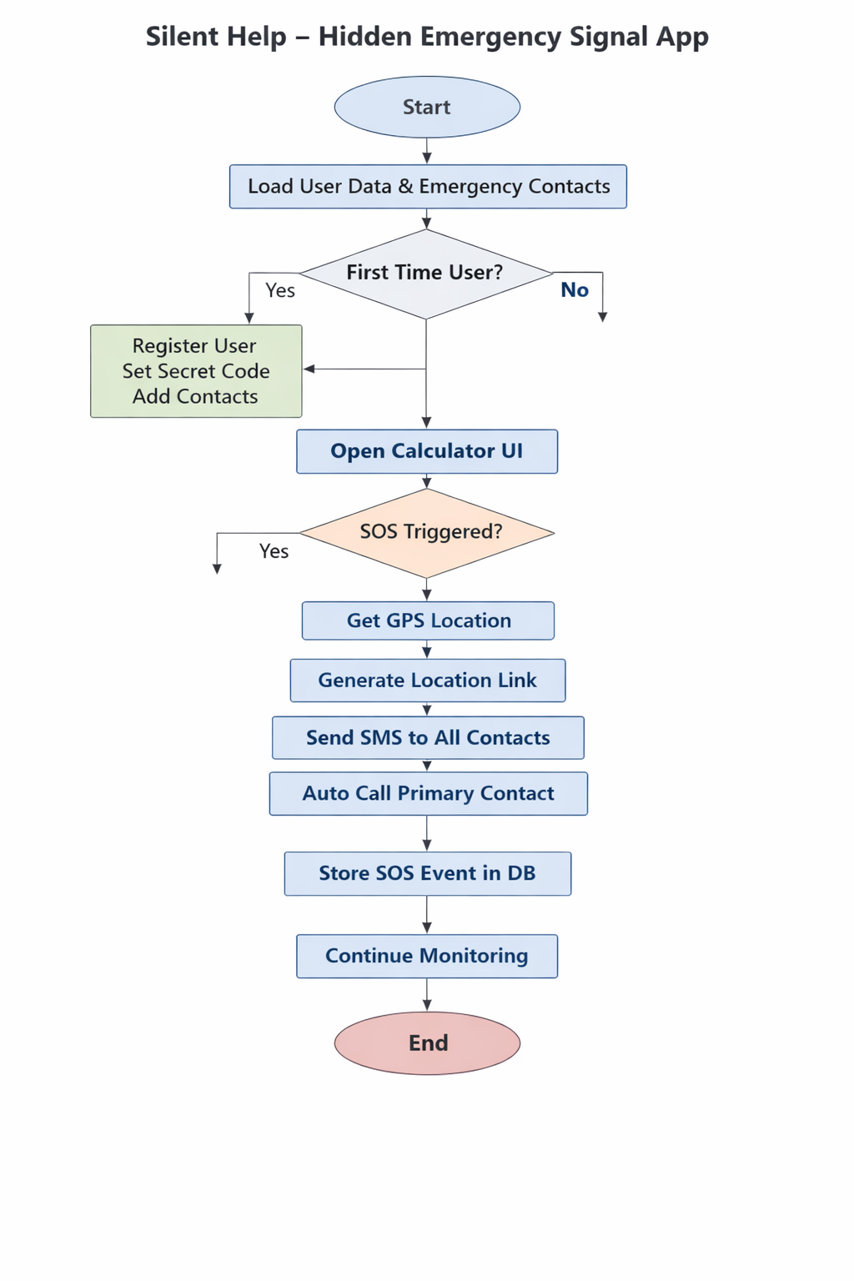

5.3 Data Flow Diagram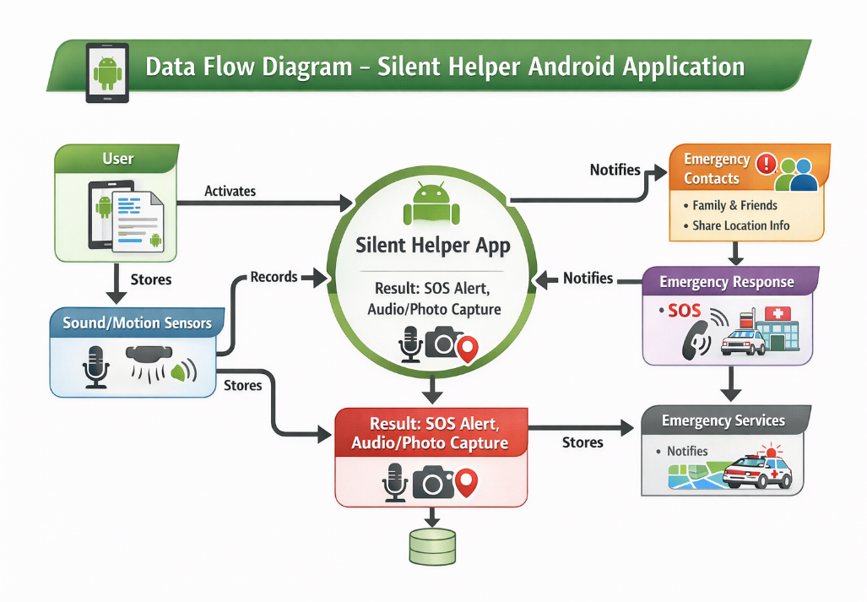
5.4 Class Diagram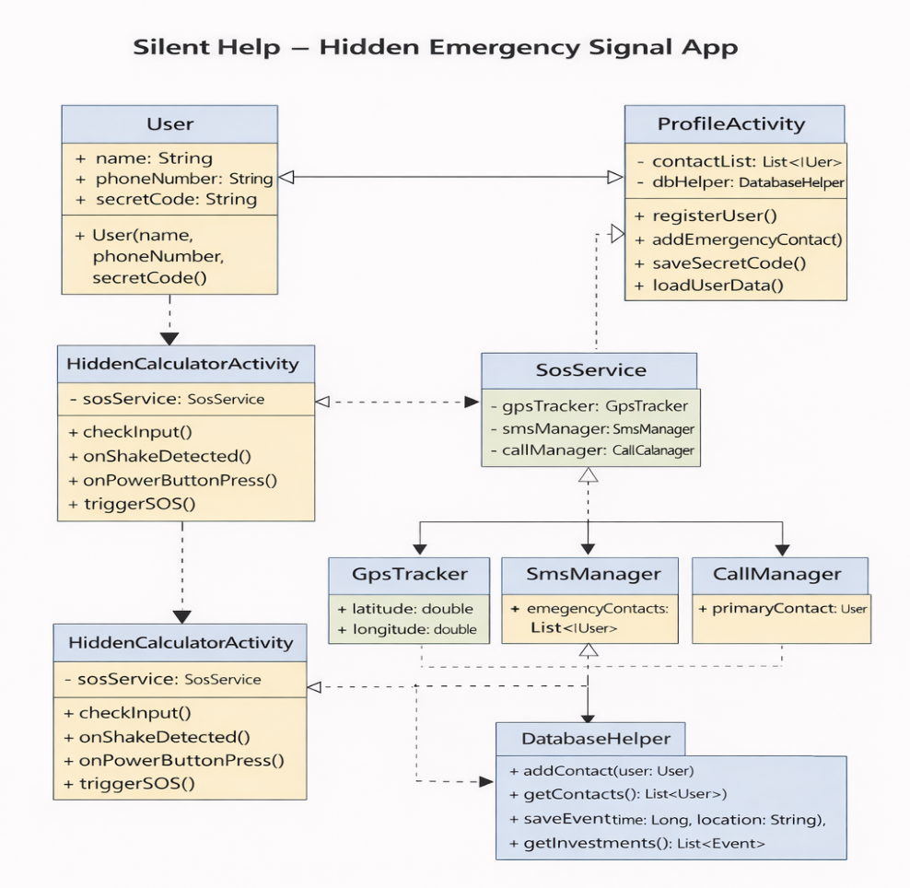

5.5 Use Case Diagram
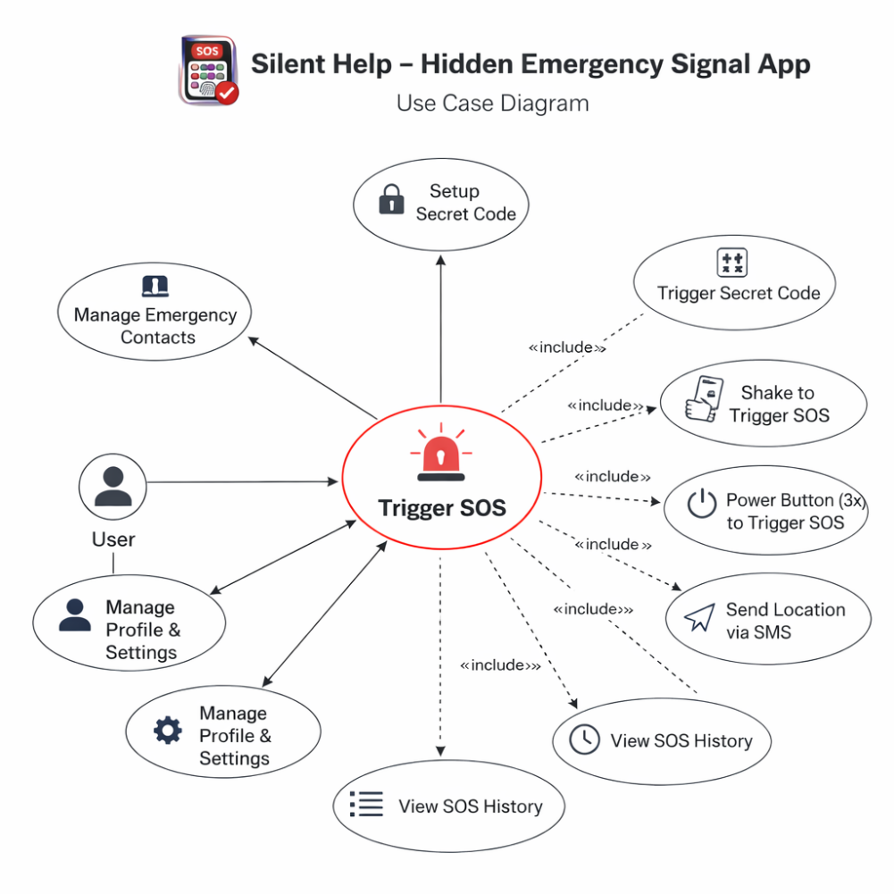
5.6 Sequence Diagram
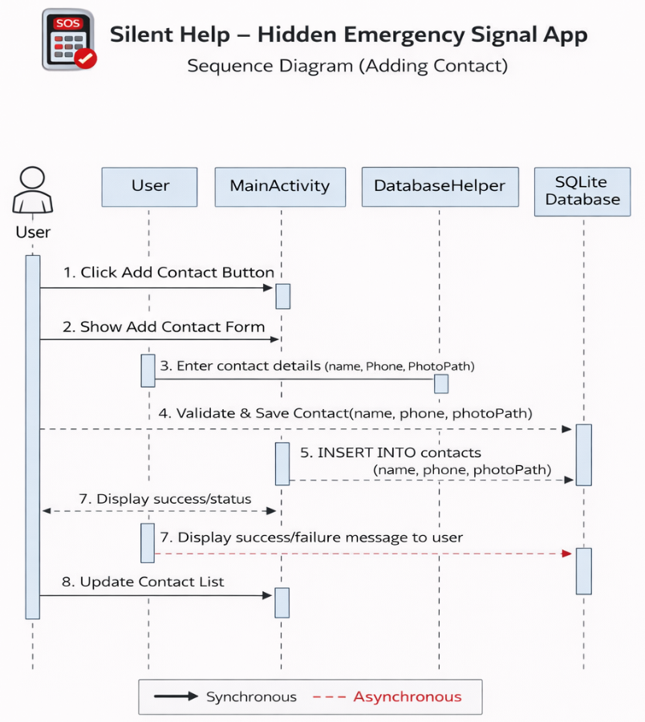
5.7 Activity Diagram
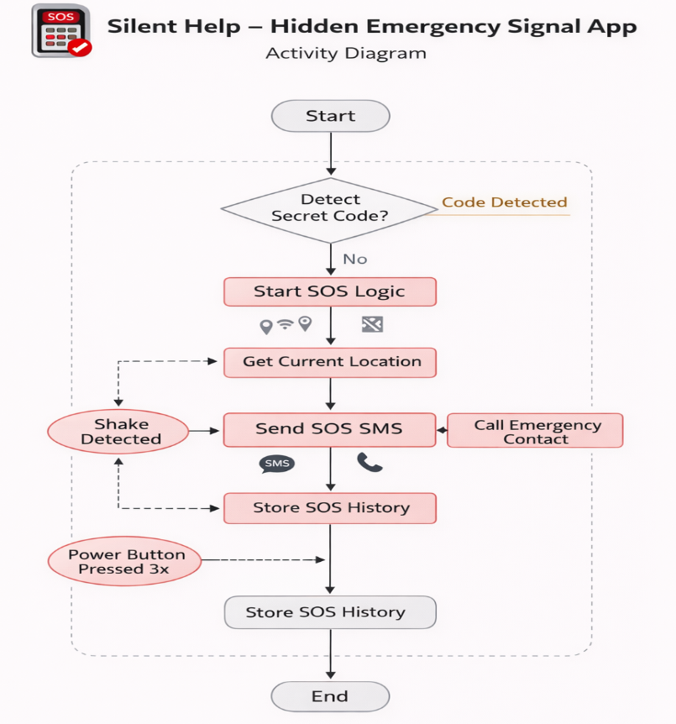
5.8 Database Design
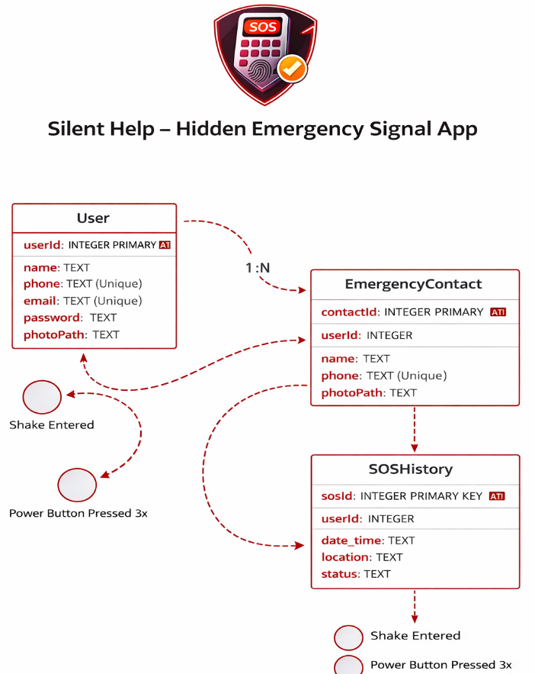

5.9 Relationship Diagram

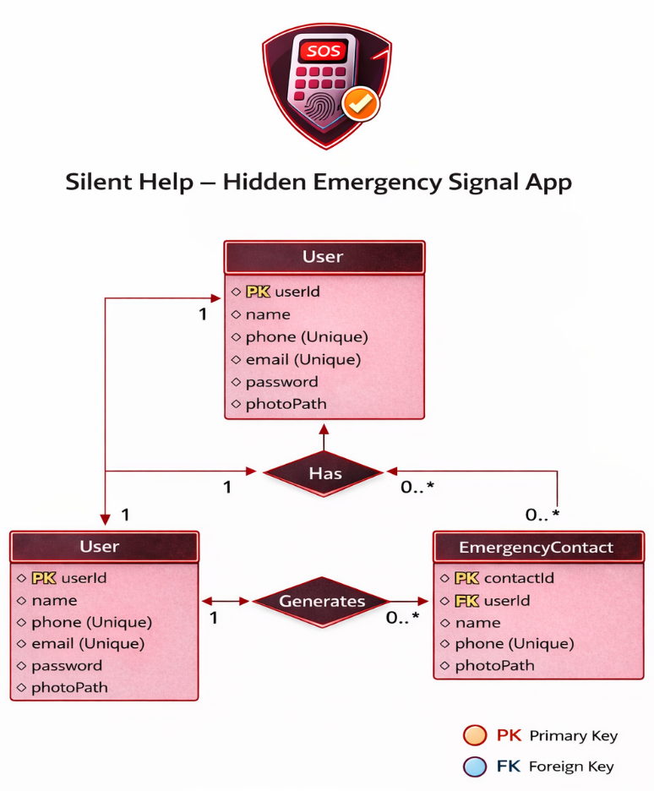

5.10 Menu Design & Screen Design

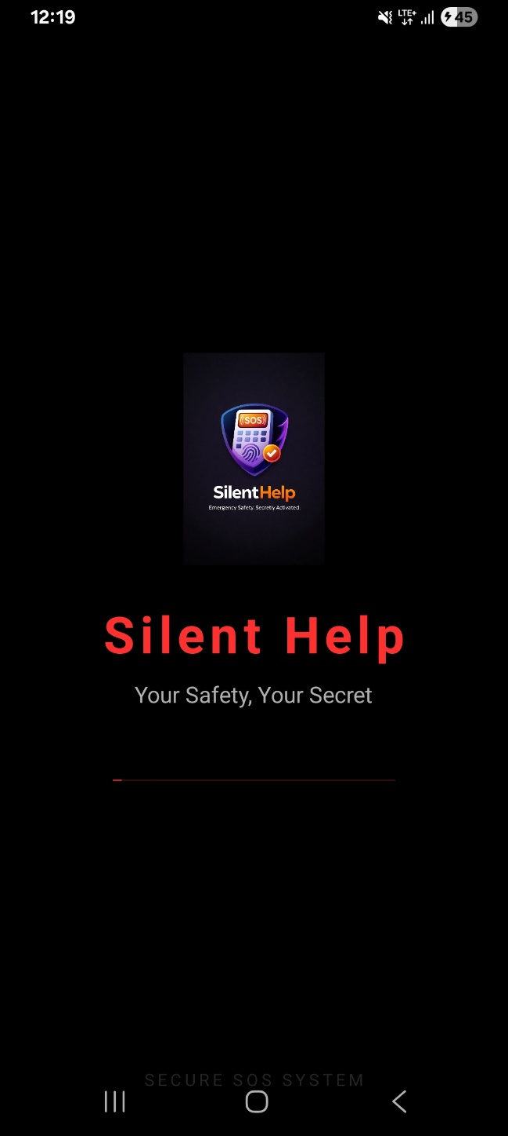 | 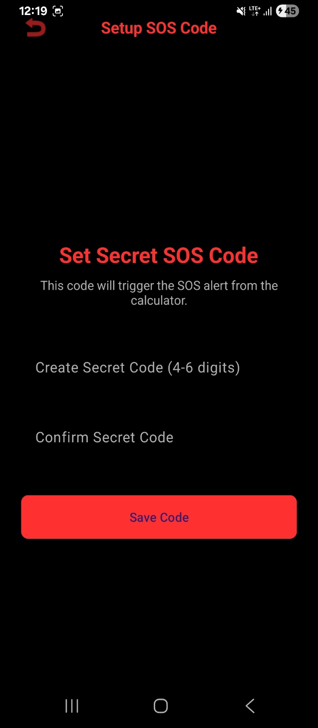

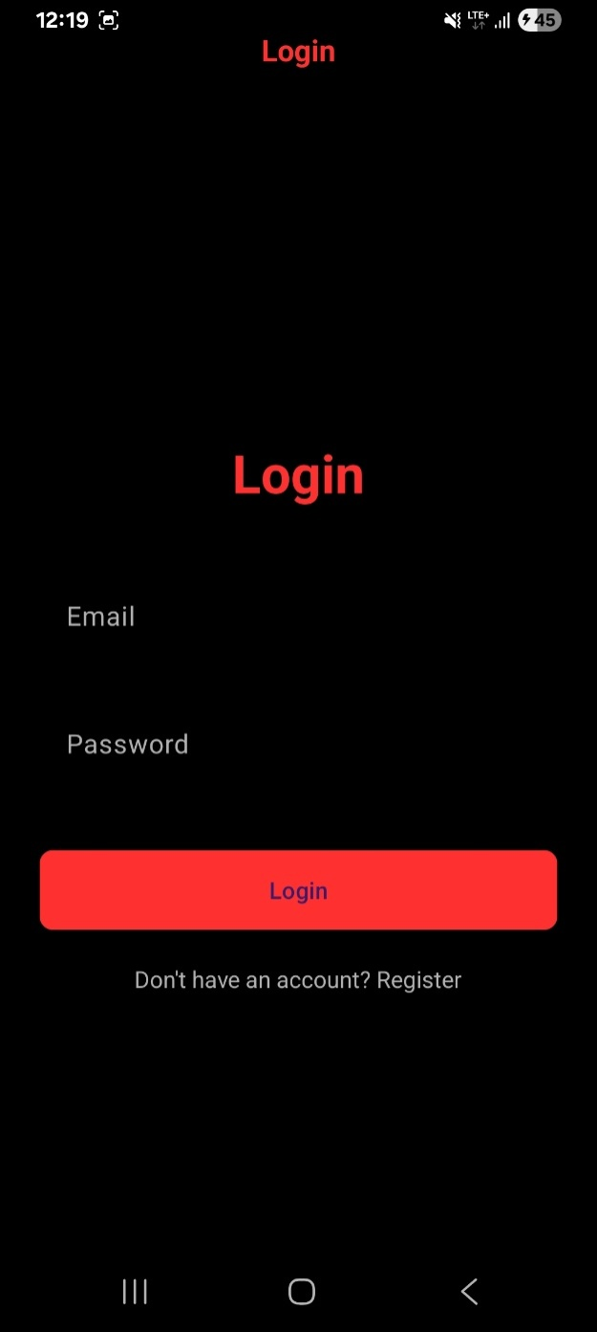 | 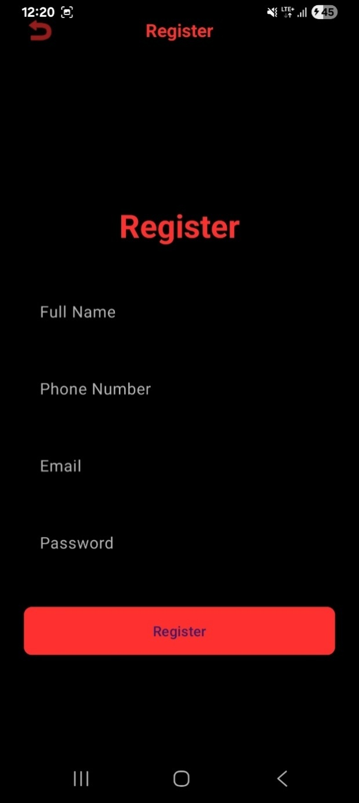

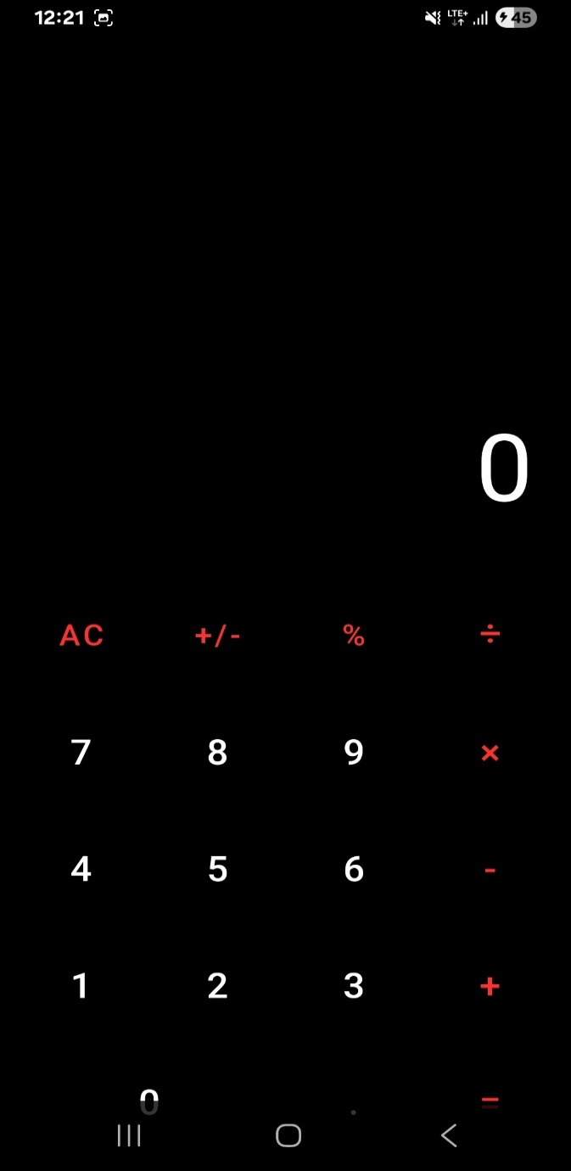 | 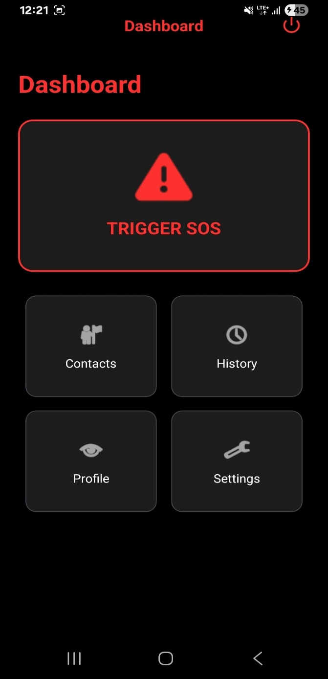

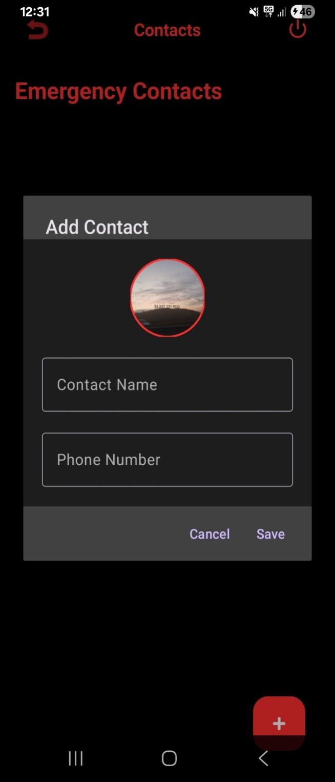 | 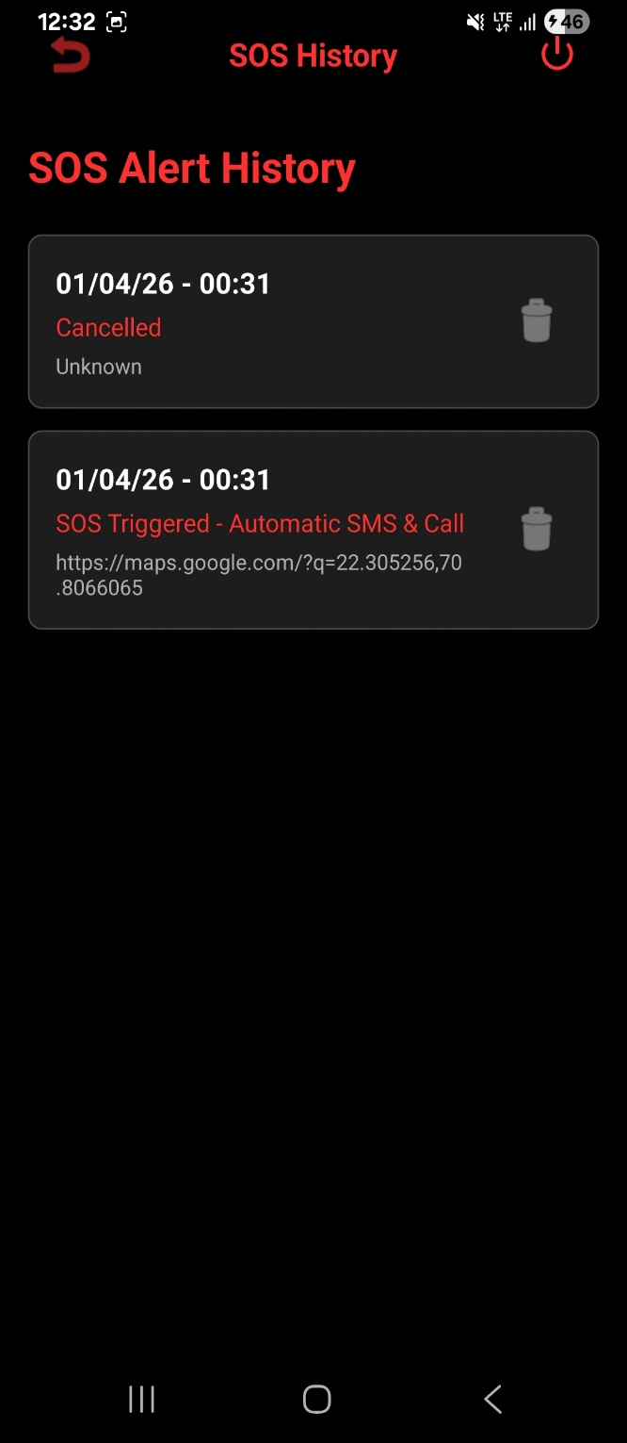

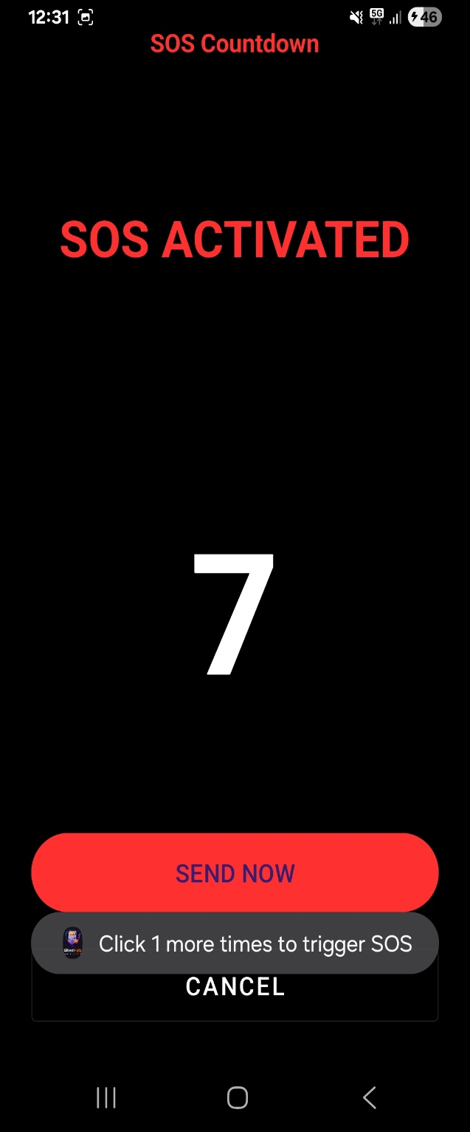 | 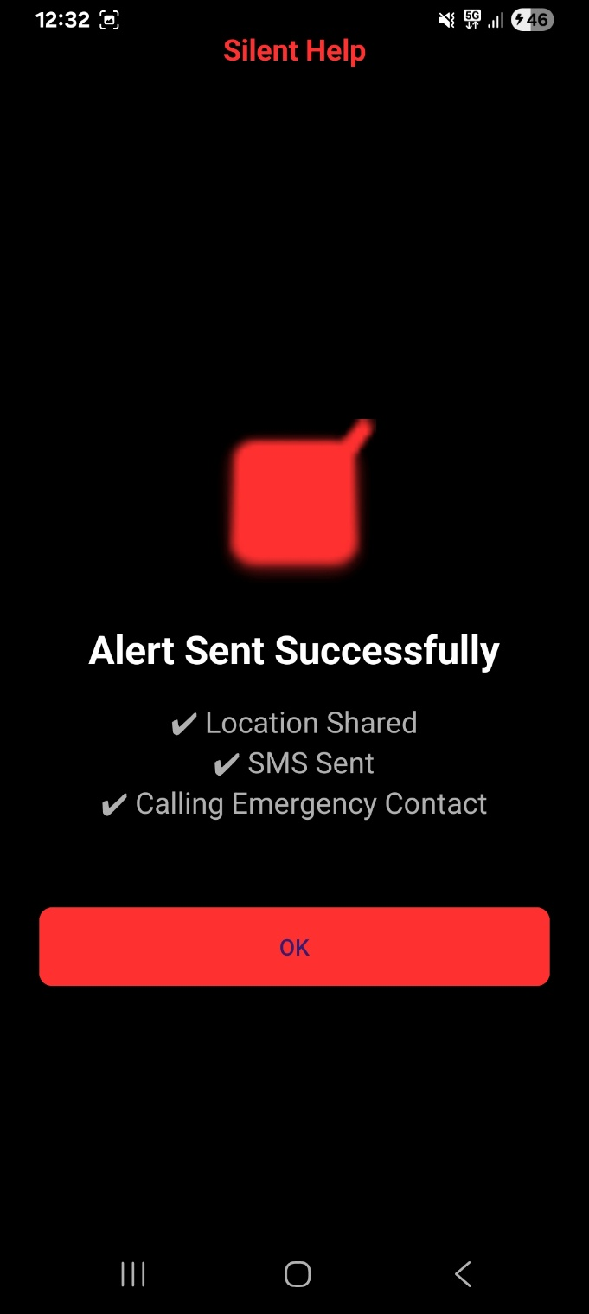

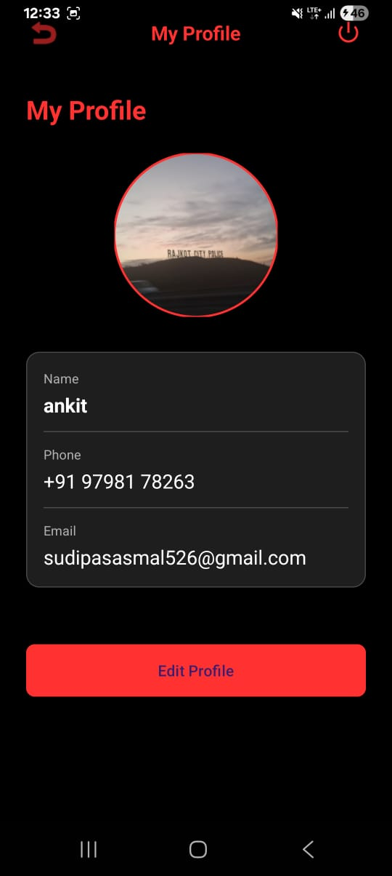 | 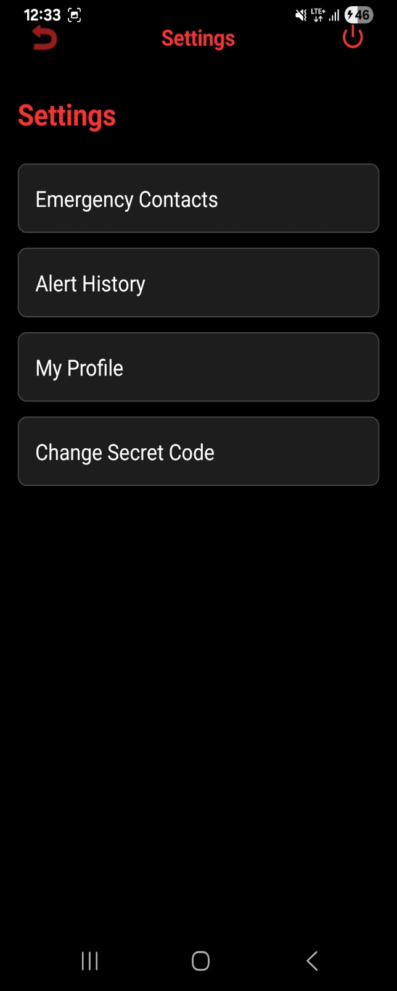

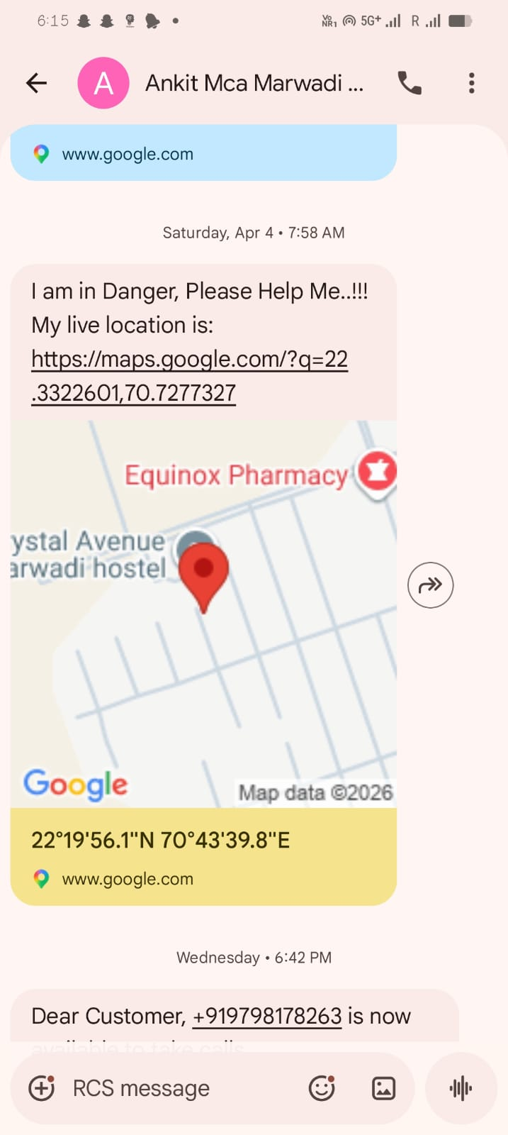

6. CONCLUSION
The Silent Help – Hidden Emergency Signal App is designed as a smart and discreet safety solution that enables users to seek help in critical situations without drawing attention. By integrating hidden triggers such as device shaking or pressing the power button multiple times, the application ensures that emergency alerts can be activated quickly and silently.
The system effectively manages user data, emergency contacts, and SOS history using a well-structured database design, ensuring reliability and efficient data handling. The use of secure storage and unique identifiers enhances both privacy and data integrity.
This project demonstrates the importance of combining technology with personal safety, offering a practical tool that can be especially useful in situations where openly asking for help is not possible. The intuitive user interface, fast response mechanism, and automated alert system make the application both user-friendly and dependable.
In conclusion, the app provides a powerful, innovative, and life-saving solution, highlighting how modern mobile technologies can be leveraged to improve personal security and emergency response systems.

7. LEARNING DURING PROJECT WORK
Through the development of the Silent Help – Hidden Emergency Signal App, I gained strong practical experience in Android app development using both Java and Kotlin. I learned how to design user interfaces using XML and follow Material Design principles to create clean, intuitive, and user-friendly layouts. Working on this project also helped me understand how GPS and location services function in real-time, enabling the app to accurately track and share the user’s location during emergencies.
Key Technical Learnings:
- Haptic Design Patterns: I learned that haptics are not just "vibrations" but a form of communication. Implementing the Vibrator class with different waveforms taught me how to provide non-visual feedback to users, making the app accessible and "tactile."

- Native Performance Optimization:Working with Java and XML on high-end devices taught me how to optimize layouts using ConstraintLayout to prevent "overdraw," ensuring that animations run at a fluid 120Hz.

- The "Privacy-First" Mindset:I learned the technical challenges of building a 100% offline app. Without external APIs, every calculation and data storage (using SharedPreferences) had to be perfectly architected to stay local and secure.

- UI/UX for Focus:Designing the "Cyber-Minimalist" theme taught me how color theory (using #090A0E and #00E676) can reduce eye strain and help users focus on complex financial data for longer periods.

8. BIBLIOGRAPHY
This section acknowledges the various sources, documentation, and references used to ensure the accuracy, functionality, and technical reliability of the application.
8.1 Online References
➤Emergency & Safety Features:
- Android Developers: Location Services API – Used for implementing real-time GPS tracking and sharing user location during emergencies.
- Android Developers: SMS Manager API – Reference for sending automatic SOS messages to emergency contacts.
- Android Developers: Sensor Framework (Accelerometer) – Used for implementing shake detection as a hidden trigger for SOS activation.
➤Android Development (Official Documentation):
- Android Developers Portal: Activity Lifecycle & App Components – Reference for managing app behavior and background processes.
- Android UI/UX: Material Design Components – Used for designing clean, user-friendly, and responsive interfaces.
- Android Developers: Runtime Permissions Guide – Reference for handling permissions like SMS, Location, and Sensors securely.
- Android Developers: Room Database / SQLite – Used for storing user data, emergency contacts, and SOS history efficiently.
➤Community & Learning Resources:
- Stack Overflow: Android Development Discussions – Used for resolving coding issues and debugging errors during development.
- GeeksforGeeks: Android Tutorials & Examples – Helpful for understanding implementation of features like SMS, database, and sensors.
- ✓YouTube Tutorials: Android App Development Guides – Visual learning resources for UI design and feature implementation.

8.2 Offline References
➤Android Programming Books (Java)
- Used for understanding core concepts of Android development, including UI design, activity lifecycle, and application logic.
- Head First Android Development: Used for understanding Android fundamentals such as Activity Lifecycle, UI design, and app navigation.
- Android Programming: The Big Nerd Ranch Guide:Reference for implementing core Android features including layouts, intents, and background services.
➤College Notes & Study Material
- Provided foundational knowledge and theoretical understanding of mobile application development and database management.
➤Classroom Lectures:
- Helped in gaining practical insights into Android components, permissions handling, and real-time application development.
➤Practical Lab Manuals
- Used as a hands-on guide for implementing features such as SQLite database, sensors, and SMS functionality

